JS1990
- Deck Swabber
- Member

- 28 posts
- Gender:Female
- Location:South Africa
- Interests:Aspiring Writer, living adventures imagined behind closed eyes.
Yoga lover, red wine enthusiast.
Posted August 11, 2013 · Report post
Hi all.
I hope you are all keeping well.
I have a question regarding the wooden statues that were so often found at the front of the ships - mermaids etc. Do they have a significance? What did they represent/relate to? Were there specific ones for specific countries or departments etc?
Forgive me if there is already a post about this - I am just musing here, and would appreciate any advice or opinions
Warmest regards,
Jacqui

Daniel
- Pyrate Captain
- 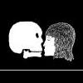
- Member

- 652 posts
- Gender:Male
- Location:McLean, VA
- Interests:History, pirates, fiction, writing, writing historical fiction about pirates, jokes, games, law.
Posted August 11, 2013 · Report post
Those statues are called figureheads. Most likely they were once thought to help the ship find her way, much like the eyes that used to be painted on ancient Greek and Phoenician ships, and over time they evolved into general symbols of good luck. They were individual to each ship, no special relationship to the country the ship sailed for. They were occasionally related to the ship's name; I have seen a painting of Drake's Golden Hind with a golden deer (hind) for a figurehead. The Golden Hind's name was changed from the Pelican, and I don't know if they changed the figurehead when they changed the name. But that was unusual; seamen thought it was bad luckt o change a ship's name, so it was rarely done.

Swashbuckler 1700
- Dread Pyrate
- 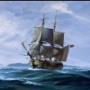
- Member

- 1,115 posts
- Gender:Male
- Location:Europe
- Interests:pyrates, pryvateers, naval military and other history, different books, good movies, music (a little bit), drawing, games,...
Posted August 11, 2013 (edited) · Report post
I am sorry if you don't feel that I was helpful but here is something I have noticed about figurehead
The figure heads varied. Women were popular but there were men as well. Animals were really popular in Warships.
At least to me it seems that around 1600s and 1700s a lion was really common, especially in Dutch and English ships, though also other nation's ship. Same with horses. However there seems to be very little logic or anything like that.
Examples. I post these even while it is not actually related to the question.
drawling from 1680s
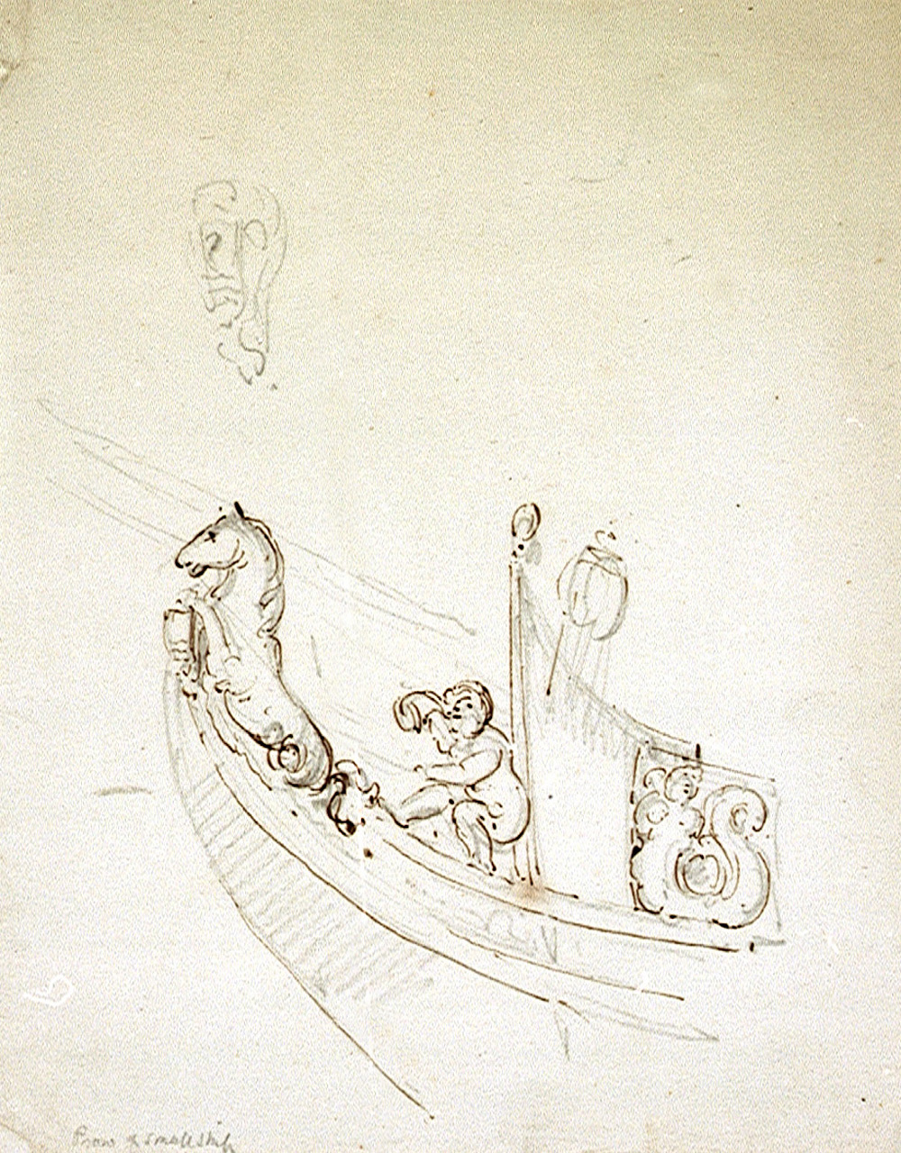
A dutch figurehead from a ship model in 1720s has a mermaid
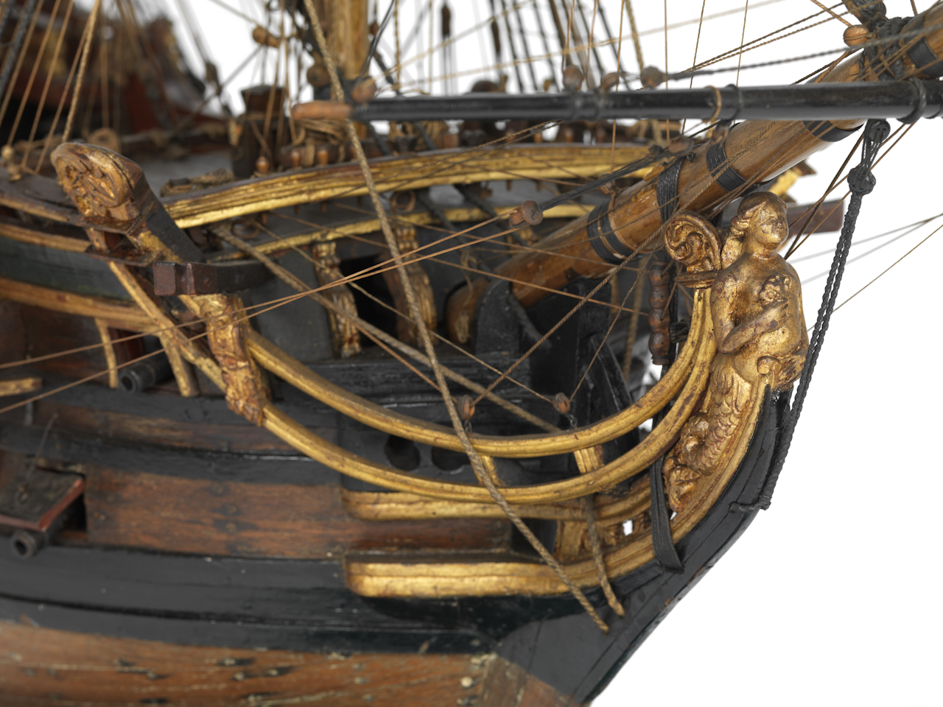
A figure head of a ancient warrior from 1780s
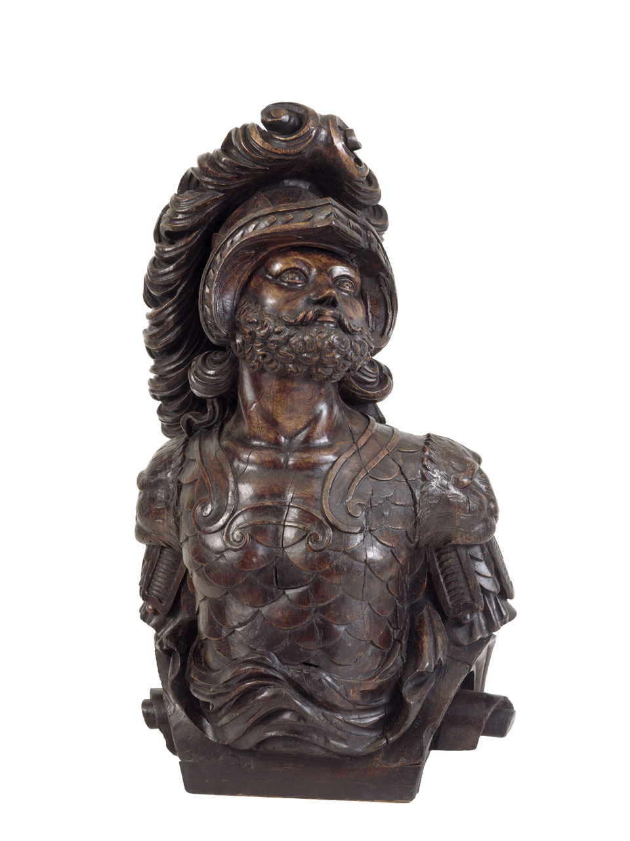
a circa 1720 figurehead, English
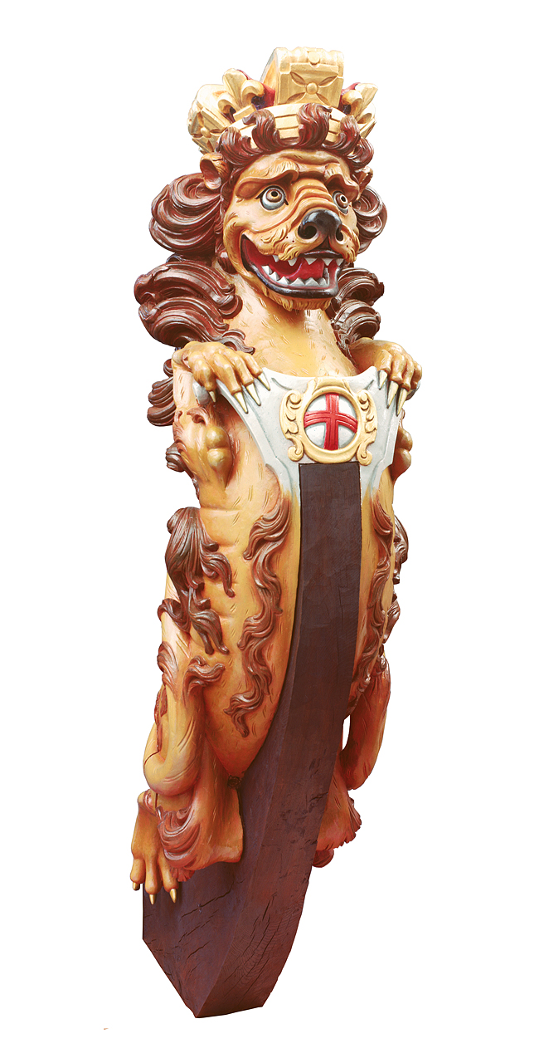
here is description for it
Full-length, polychrome-painted figurehead depicting a heraldic crowned lion, holding a small badge of the cross of Saint George at the breast, where it fitted over the stem-head. This is a rare survival of a standard Royal Naval lion figurehead from a small warship probably of the fourth or fifth rate. Its present paint scheme is as restored by the late Kim Allen of Westerham, Kent, in the 1970s but probably much more subtly than most were originally painted: many were largely plain gold, or yellow simulating it. Such lion figures were the standard figureheads of all Royal Naval ships which bore them and were not of a size to warrant an individual design, as was usually the case with first-, second- and (more variably) third-rates. They were also standard in other European navies allowing for local differences of design. This is one of only two surviving British examples: the other, which is larger and probably a little later, supports the gable of the Red Lion Inn at Martlesham in Suffolk. There is an older, probably 17th-century example in Sussex, but in poor condition and of uncertain origin. FHD0089 is another example in the Museum collection, thought to be of 18th-century north European origin.
Edited August 11, 2013 by Swashbuckler 1700

Jas. Hook
- Scourge o' the 7 Seas
- Member

- 1,650 posts
- Gender:Male
- Location:Long Island NY
- Interests:Fishing & Piracy
Posted August 12, 2013 · Report post
HMS Bounty figurehead. Young woman in a riding habit.
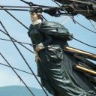

Dutchman
- Has anyone seen my cousin?
- Admin

- 1,773 posts
- Gender:Male
- Location:tidewater virginia
Posted August 13, 2013 · Report post
http://www.mysticseaport.org/locations/exhibits/figureheads/
a while back i found a thesis someone did on the collection at Mystic Sseaport but cant put my hands on it right now. if you do a search you may be able to find it. It was a bit beefy to download but it had a great history and pictures of all the ones in their collection.

Mission
- Goat Specialist
- Admin

- 5,081 posts
- Gender:Male
- Location:Monroe, MI
- Interests:Scholarly piracy, designing and creating haunted house rooms and props, movies, abstract thinking, abstruse thinking, obstructive thinking, ideating, random thinking, movies, cartoons, movies, movies scores, cycling, world peace and small furry dogs, movies, writing, drawing, personal skills training, gremlins and, of course, lest I forget, movies.
Posted August 13, 2013 · Report post
Just Googling, I found a couple of things on the figurehead collection at Mystic Seaport (which appears to be pretty impressive - thanks for bringing it up, Dutch):
This page on the Mystic Seaport site contains a number links to different figureheads at the museum.
And I believe this is the PDF you were talking about, Dutch. It's a Master's Degree thesis on the figureheads there from 1984. It's not the best scan in the world, but if this is your topic, it sure appears to be extensive.
Note: I am going to edit the title of this thread to include the word 'figureheads" to make it easier to find in the future since I didn't see another thread on this topic here at the Pub.

Jas. Hook
- Scourge o' the 7 Seas
- Member

- 1,650 posts
- Gender:Male
- Location:Long Island NY
- Interests:Fishing & Piracy
Posted August 13, 2013 · Report post
One of the best figureheads I saw was on a sailboat that was moored and being restored at a dock in Mystic, CT by the Main Street drawbridge and not at the Seaport.
The figurehead was of a naked woman holding an artist palette and brushes with a Chow dog at her side.
As the expression goes... there in lays a story. I wish I had a photo of it.
Jas. Hook

Mission
- Goat Specialist
- Admin

- 5,081 posts
- Gender:Male
- Location:Monroe, MI
- Interests:Scholarly piracy, designing and creating haunted house rooms and props, movies, abstract thinking, abstruse thinking, obstructive thinking, ideating, random thinking, movies, cartoons, movies, movies scores, cycling, world peace and small furry dogs, movies, writing, drawing, personal skills training, gremlins and, of course, lest I forget, movies.
Posted August 1 · Report post
A rare reference to a figurehead in a pirate document. (Although it could be argued that Philip Roche was less a traditional ship-taking pirate than just a mutineer.)
"And when they came to Dartmouth the s[ai]d Peirce Cullen ordered the Examinate to procure a Carpenter and to agree with him to run a spare Deck upon the Vessel [the 40 Ton Ship St. Peter] and to alter her to a Snow by taking down the Misen Mast, and he the sd Cullen pro[c]ured one Taylor a Carpenter to doe the same; And he the sd Cullen and the aforesd Neal before she came to Dartmouth took off the Figure that was in her Head and painted her. And at Dartmouth the sd Carpenter run a spare Deck upon her and took down the Mizen Mast and put up a Lyon in her Head." (Ed Fox, "31. Philip Roche The Examination of Philip Roche, 11 April, 1723. HCA 1/55, ff. 36-41", Pirates In Their Own Words, 2014, p. 149)

